**More challenges to try**

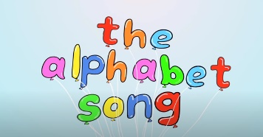Learn the alphabet song[**https://youtu.be/0FfcNgYCW18**](https://youtu.be/0FfcNgYCW18)

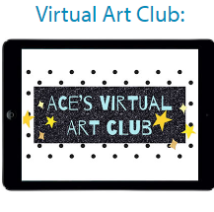

**Join Miss Beacham in ACE’S Virtual Art Club- follow the link through “Learning” on our website.**

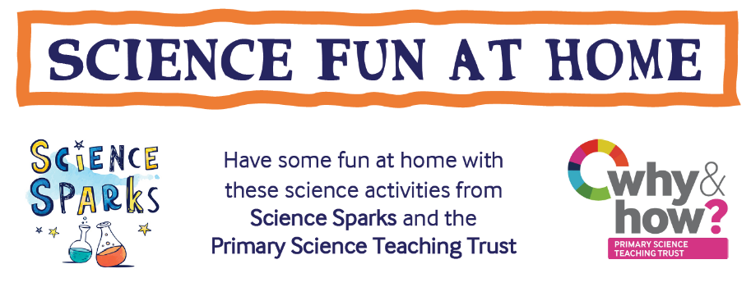

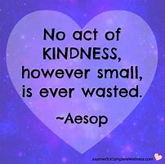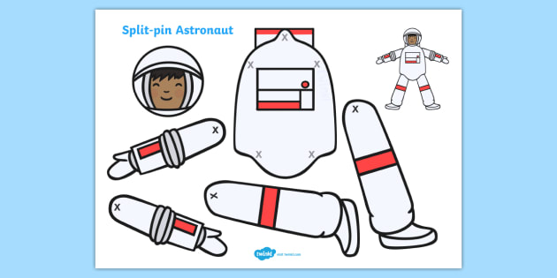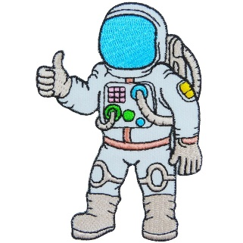

Do something kind for someone in your house-

Tidy your bedroom Help make your lunch

Give someone a cuddle Help set the table

Can you think of some more?

Find out- what do astronauts eat?

Make a moving astronaut



It is national Puzzle day on Friday 29th January. Open the PDF file above and try some of the fun challenges. Send in your photos please.